附件2
论文格式模版

议题1

A STUDY ON SALINITY INTRUSION PHENOMENA AND ITS IMPACT ON THE ENVIRONMENT

Peter Jackson¹, Paul Mathare², Silvia Clayton²

^{1.}Unitec Institute of Technology New Zealand pj@yahoo.com
² Kyoto University, DPRI, Japan

Abstract:Times New Roman, 11 pt, Justified. The tampering of the hydro-geological systems, and the resulting by product of these actions unless properly managed, could be harmful to the resource as well as to the environment as a whole. Approximately 200 words or less.
Key Words: Salinity intrusion, Ground water quality

1. Introduction
Text - Times New Roman 11 Pt, Justified, Alignment centered.
2. Body of paper
Text – Times New Roman 11 Pt, Justified, alignment centered.
2.1 Long term variation
Times New Roman 10 Pt, bold, Alignment centered.

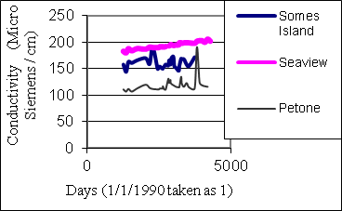
Fig 1. The Location

Table - 1 Piezometric head with time

Acknowledgements

References
[1] De Silva. S., Jason. M., and Jones. A., (2003): Comparative analysis of salinity intrusion, Proceedings of the 30th Congress of the IAHR, Theme B, pp.565-572.

